**Ideation Phase Empathize & Discover**

|  |  |
| --- | --- |
| Date | 24 November 2023 |
| Team ID | 87A30A6024D629493A648649AC44C931 |
| Project Name | Electronic voting system |
| Maximum Marks | 4 Marks |

**Empathy Map Canvas:**

Focuses on ensuring that decentralized identity solutions align with legal frameworks.

user-friendly experience for managing identity on the blockchain.

compliance with standards.

Collaborates with the community.

contributing to decentralized identity solutions.

compliance with existing regulations.

**Gain:**

Clear and crisp sound, relevant content options

Diverse content, easy navigation

compliance with existing regulations.

**Pain:**

Immersed in the audio experience

Quality of sound, relevant content

Listens to audio content, adjusts settings

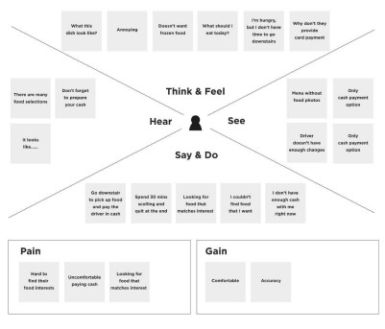

privacy and security of personal information.

Analyses the contract code and architecture for vulnerabilities.

provides feedback to developers

Actively participates in smart contract development

tools for secure contract development.

clear instructions, and assurance of data security.

transparent communication from developers.